

**voice Emotional prediction in Arabic**

**Deep Learning Course**

Prepared by:

Kinda Sulaiman: 202110811

Rayan Qoursha: 202111153

Jumana Abu-Snaineh: 202030016

Nagham Thamer Al-Otaibi: 202110560

Supervised by:

Dr-Bassam Haddad

Introduction:

Welcome to our emotion detection in audio project, a dynamic endeavor that fuses real-world emotion expressions from movies and series with synthetic instances generated by artificial intelligence. This project aims to develop a robust neural network model capable of accurately identifying emotions in diverse audio datasets. By leveraging transcription, Mel-frequency cepstral coefficient (MFCC) extraction, and a combination of authentic and AI-generated datasets, our approach ensures a comprehensive understanding of emotions across various contexts and sources. The integration of two datasets enriches the model's training, allowing it to adapt to both natural and synthesized emotional expressions. Join us on this journey from data preparation to model deployment as we explore the intricate landscape of audio emotion recognition, bridging the gap between genuine human experiences and artificial intelligence-generated content.

Challenges:

Our Arabic voices were limited in their sources and short in compilation time, so we faced some problems that affected the efficiency and accuracy of the model, such as:

1. Poor sound quality

2.There is no diversity in the voices we collected

3.Dialects are not adequately represented: The Arabic language includes different dialects, and the model has difficulty understanding and distinguishing between them.

4. the model is struggling to convert all voices to text accurately

Our dataset:

We use 2 data set the first one we collect it and the second we generate it from AI

Our data AI data

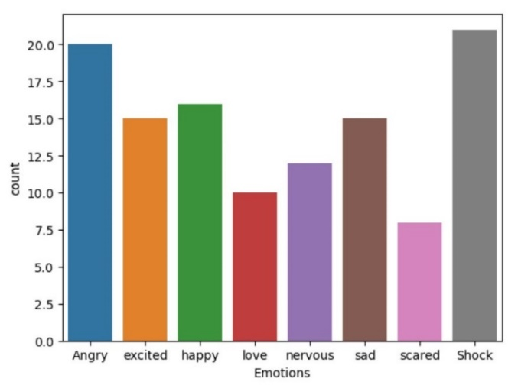 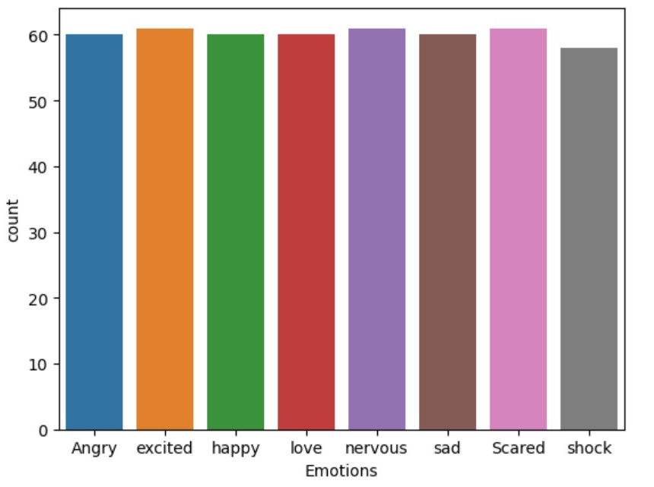

**Part 1: Frequencies**

**Code:**

1. Import the important library’s

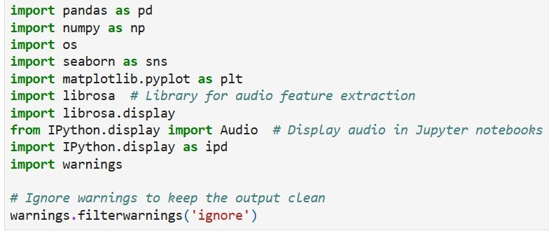

1. This code reads audio files containing emotions, divides them based on their file paths and emotion types, and stores each unit separately in their respective arrays. It walks through a specified directory, gathers file paths, and extracts emotion labels from directory names, organizing this information into two lists: one for file paths (paths) and another for emotion labels (labels). The paths list holds the full file paths of the audio units, while the labels list corresponds to the emotion labels associated with each unit.

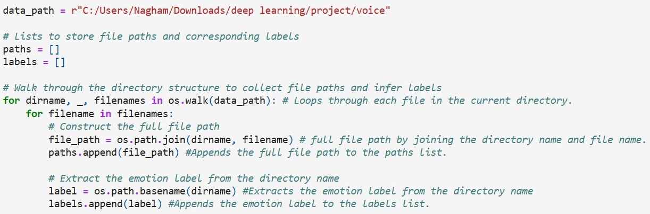

1. This code uses Pandas to create a DataFrame (df) with emotion labels and file paths. It then extracts one path per unique emotion into a new DataFrame (df_one_per_emotion). Finally, the original DataFrame (df) is updated with emotion labels and file paths, and the resulting DataFrame (df_one_per_emotion) is displayed.

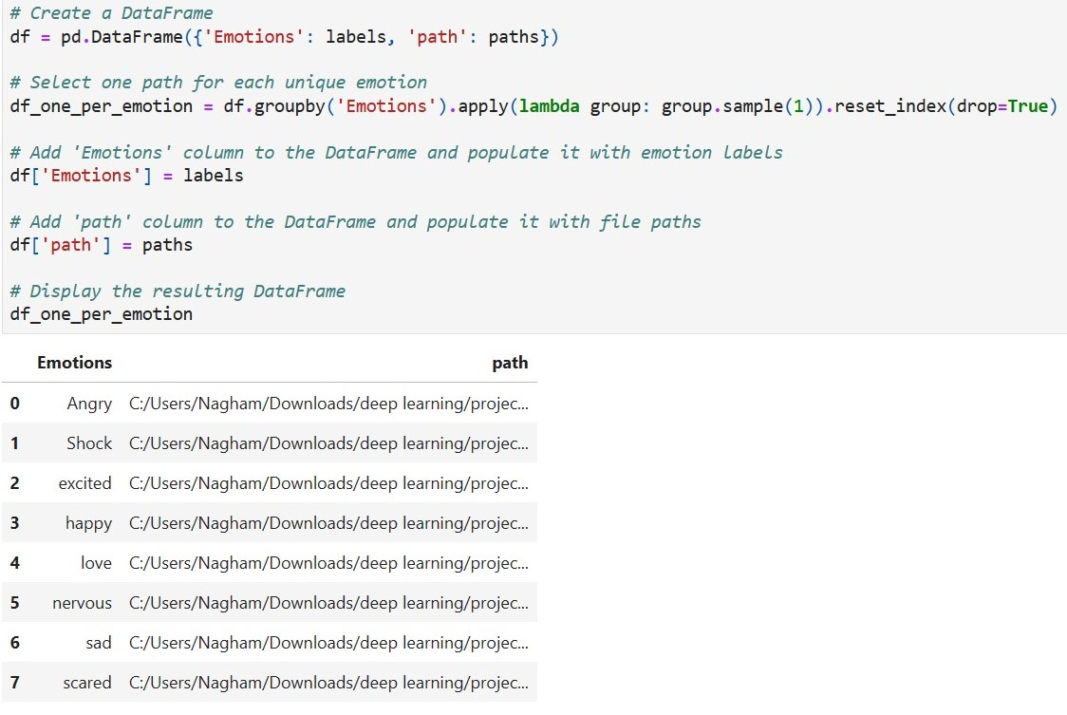

1. Count the number of each emotion

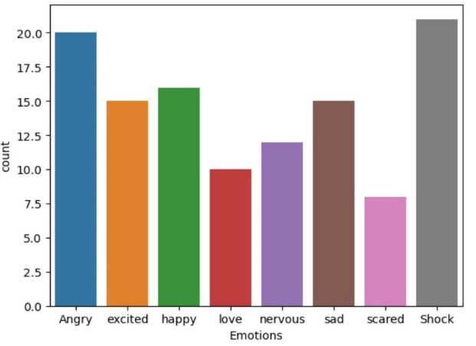 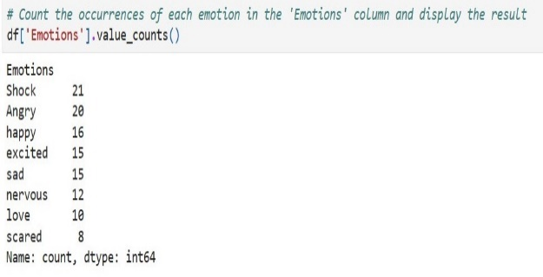

1. this code visualizes and plays the waveform of a specified audio file associated with the emotion "Angry". And all the other emotion

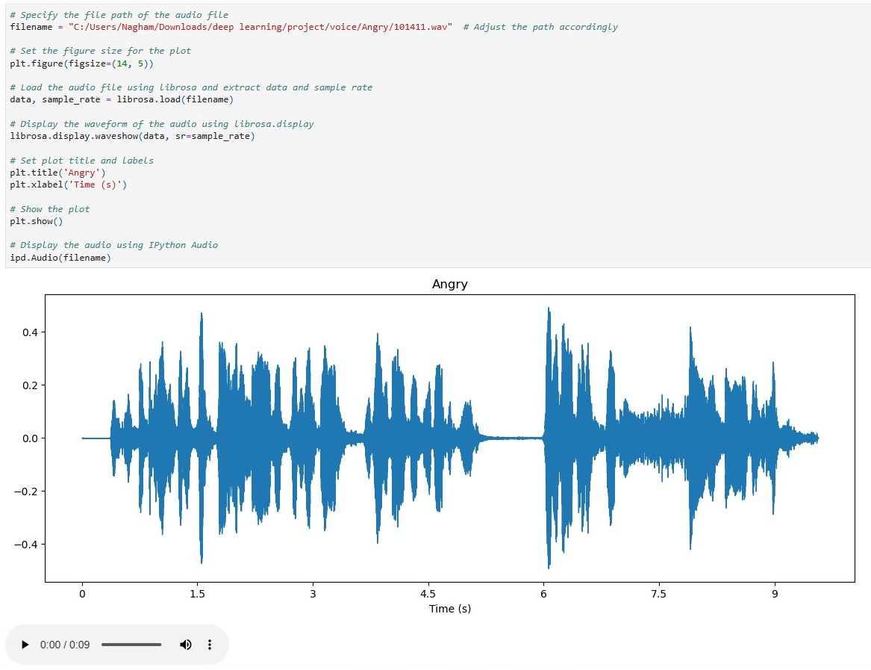

1. This function, extract_mfcc, loads an audio file, extracts 11 seconds starting from 0.2 seconds, computes the Mel-Frequency Cepstral Coefficients (MFCCs) using 40 coefficients, and returns the mean of the MFCCs. The example usage shows extracting MFCCs from the path of the first audio file in the DataFrame (df).

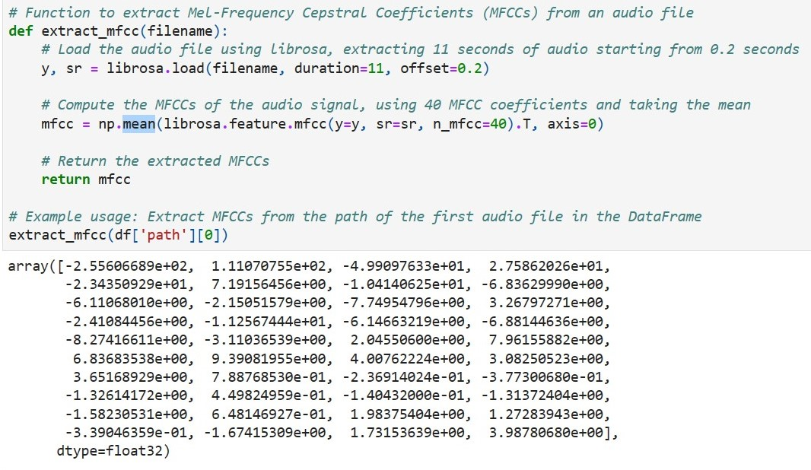

1. This code efficiently computes MFCC features for each audio file specified in the 'path' column of the DataFrame (df). It uses the apply method to apply the extract_mfcc function to each element in the 'path' column, creating a Series (or array-like object) containing the extracted MFCCs for each audio file. The result is stored in the variable X_mfcc

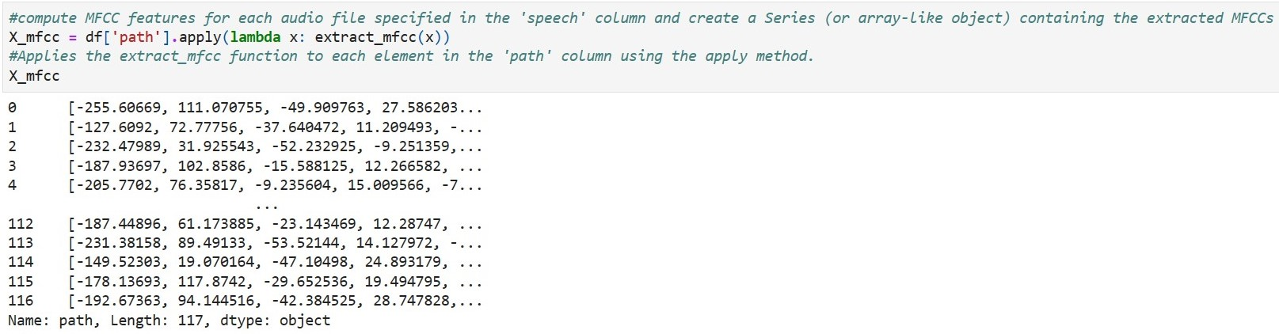

1. This code uses list comprehension to create a list 'X' from the MFCCs Series (X_mfcc). It then converts 'X' into a NumPy array for numerical operations and displays its shape, indicating the number of samples and features.

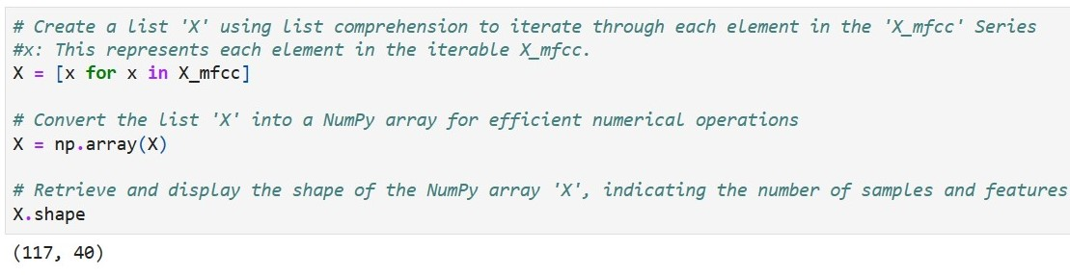

1. This code expands the dimensions of the NumPy array 'X' by adding a new axis at the end, effectively converting it into a 3D array. The modified array shape is then displayed.

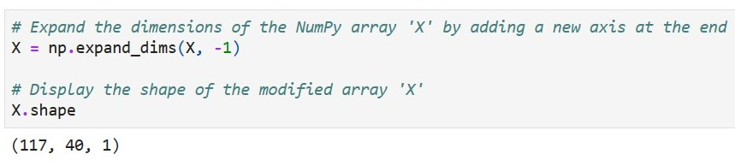

1. This code uses scikit-learn to one-hot encode the 'Emotions' column in the DataFrame (df). It converts the resulting sparse matrix into a dense NumPy array and prints its shape.

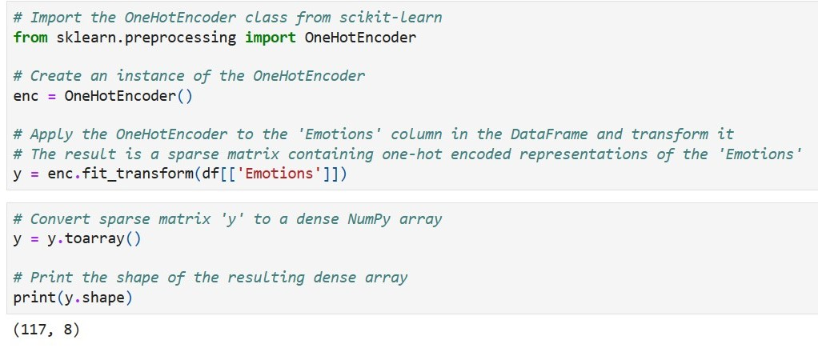

1. This code splits the dataset into training and testing sets using train_test_split. It then performs K-fold cross-validation (5 folds) with StratifiedKFold, printing the shape of each fold's training and testing sets ‘’ StratifiedKFold is a method for cross-validation that maintains the same distribution of target classes in each fold. It helps ensure balanced representation during model evaluation, which is especially important for classification tasks with imbalanced class distributions.’’

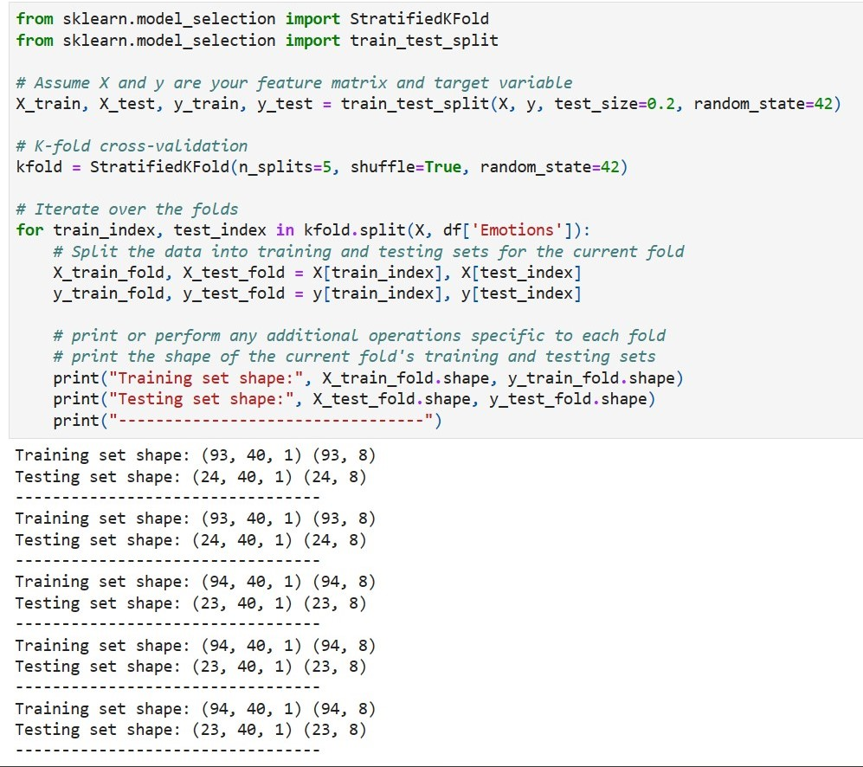

1. This code builds a neural network model for audio classification using Keras. It includes a convolutional layer, max pooling, LSTM layer, and dense layers. The model is compiled with categorical crossentropy loss and a custom Adam optimizer with a specified learning rate. Dropout layers are incorporated for regularization, and the model summary is displayed.

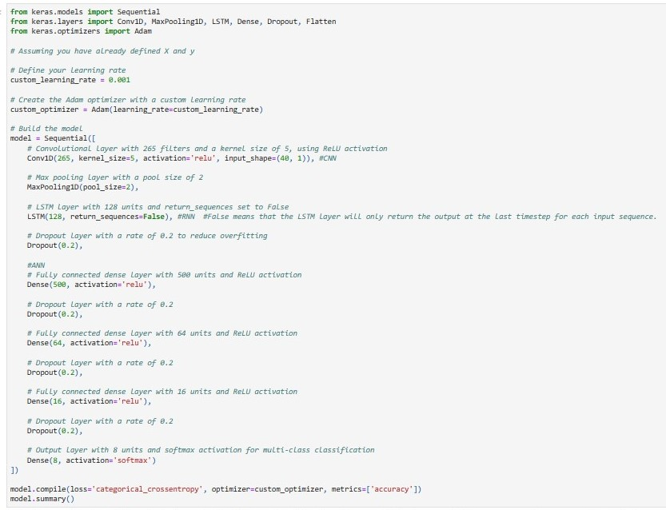

1. This code trains the neural network model using K-fold cross-validation. It iterates over folds, splits data into training and validation sets, and fits the model for 30 epochs with a batch size of 64. The training progress is printed during the process.

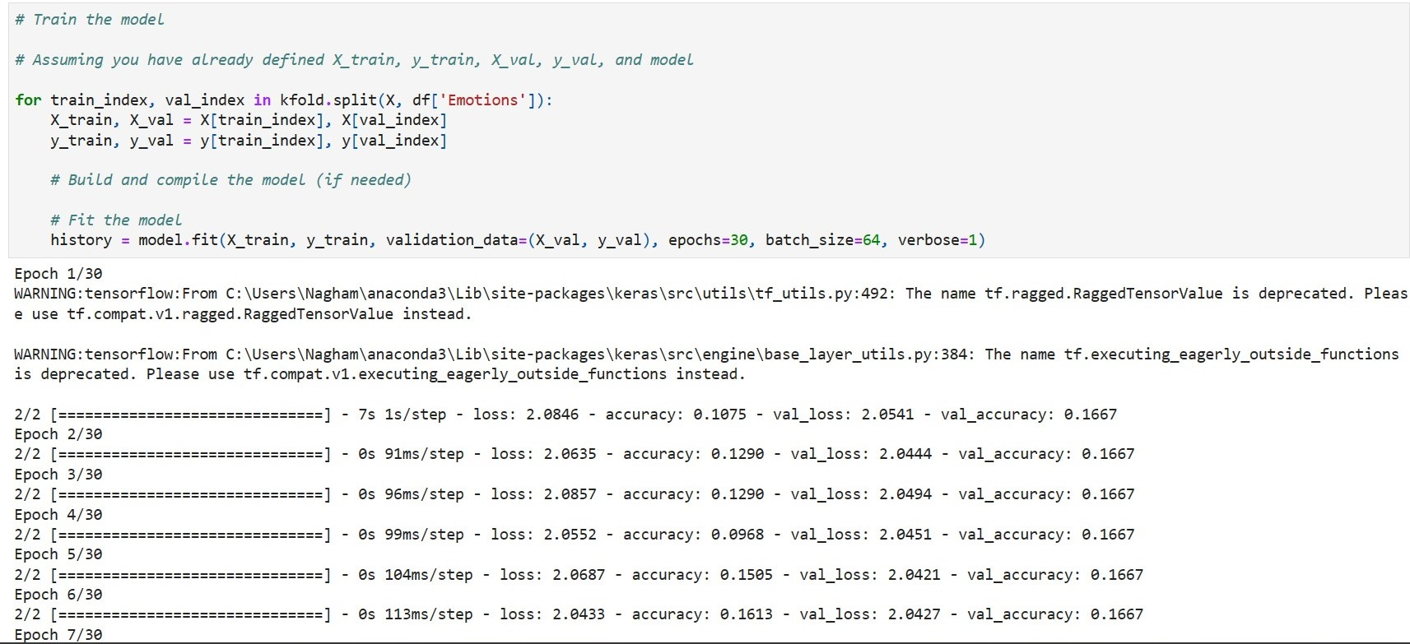

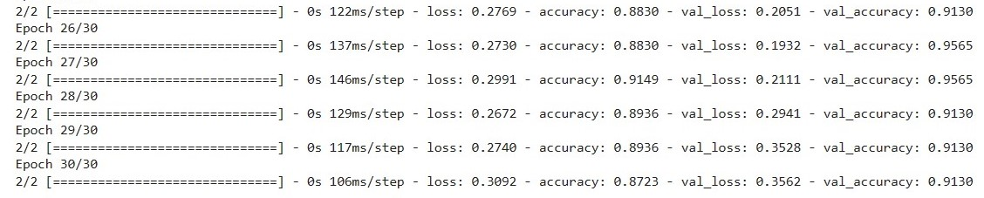

1. This code visualizes the training and validation loss over epochs for a neural network model using Matplotlib.

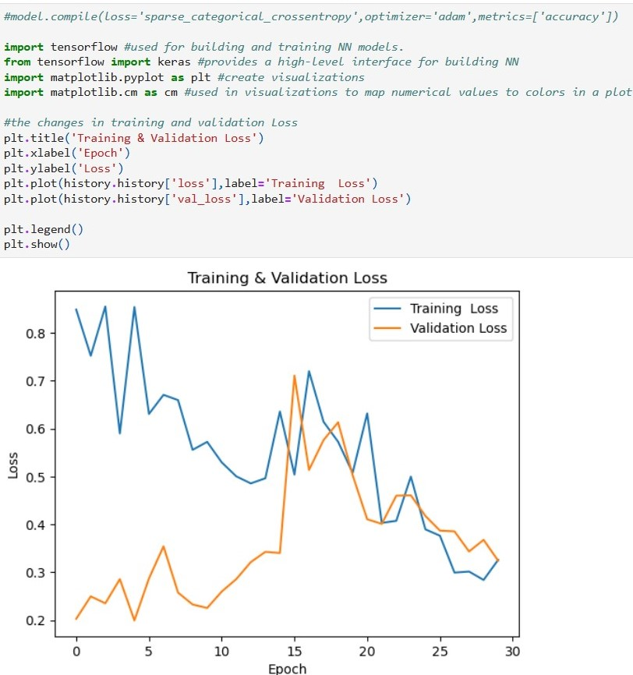

1. This code visualizes the changes in training and validation accuracy over epochs using Matplotlib. It provides a quick snapshot of the model's learning progress

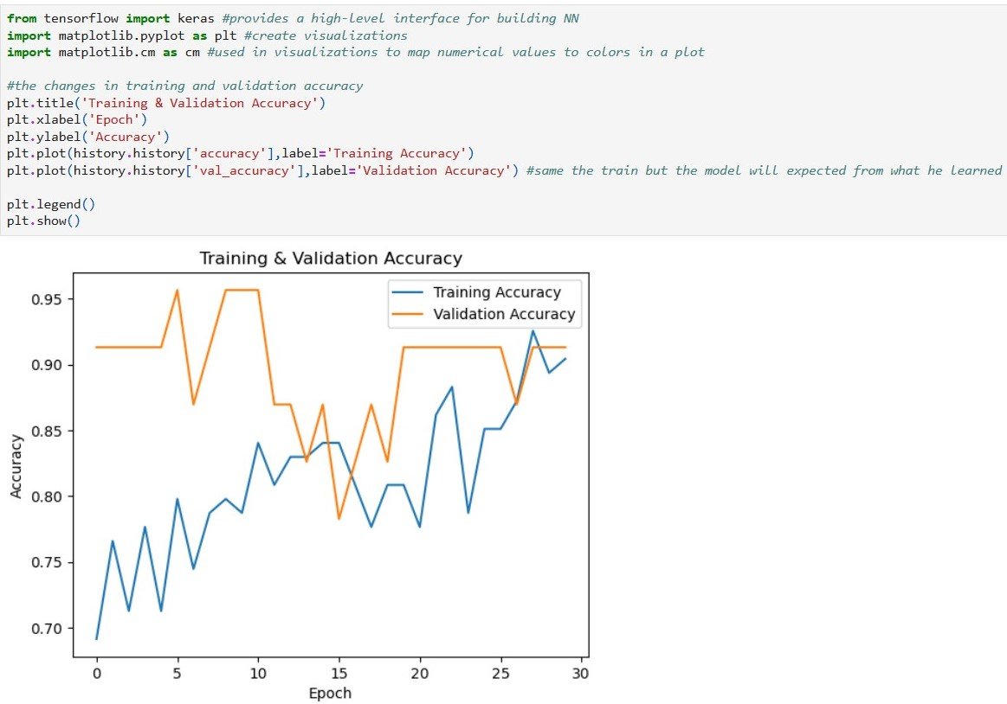

1. This code, in addition to the previous explanation, includes a line to print the shape of the reshaped input_data array.

In short, it loads an audio file, extracts MFCC features, displays the shape of the MFCCs, and reshapes them into a 1D array suitable for model input. The final line prints the shape of the input_data array.

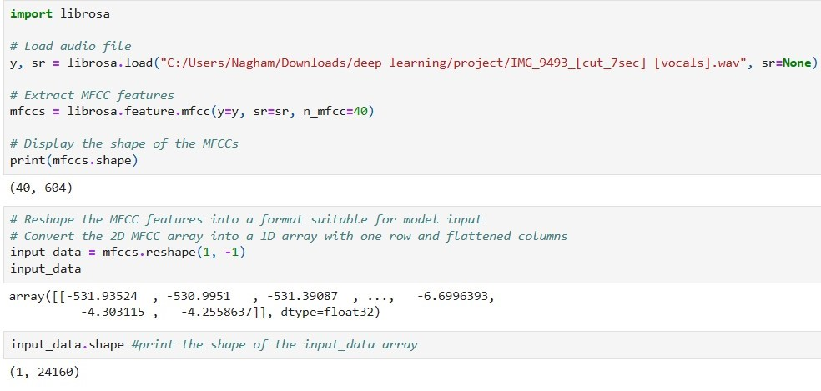

1. This code calculates the mean along the second axis of a NumPy array (mfccs) and prints the resulting shape.

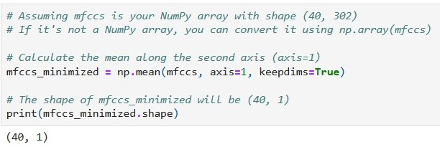

1. This code demonstrates saving and loading a trained emotion detection model in HDF5 format. It defines a function (predict_emotion) to make predictions on new audio files using the loaded model. The example usage predicts the emotion for a given audio file and plays the audio.

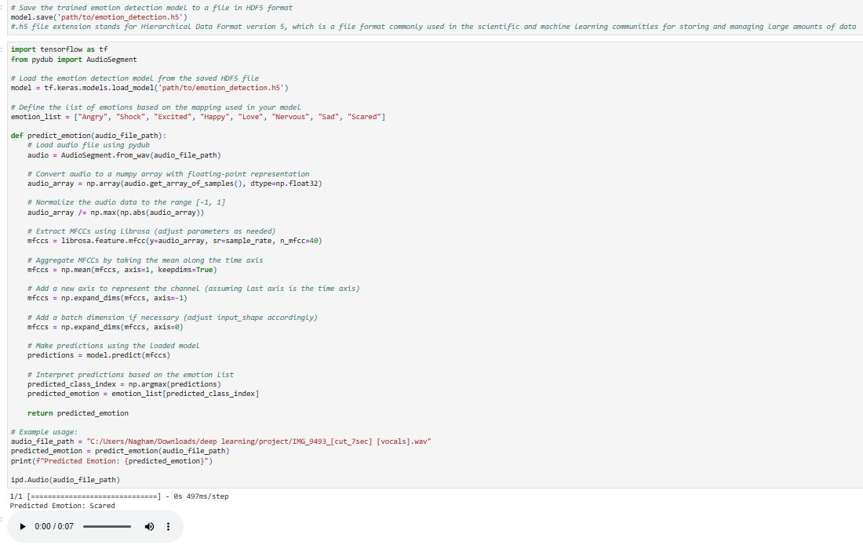

1. When predicting emotions not present in the dataset, we closely tracked the outcomes generated by the model. However, the accuracy of these predictions was limited as the dataset was small, hindering the model's ability to learn effectively.

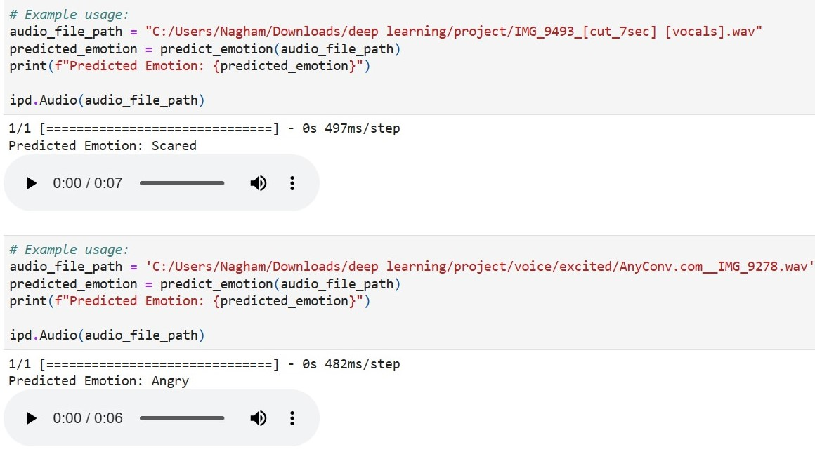

**Part 2: Frequencies and Text**

**Code:**

1. Import the important library’s

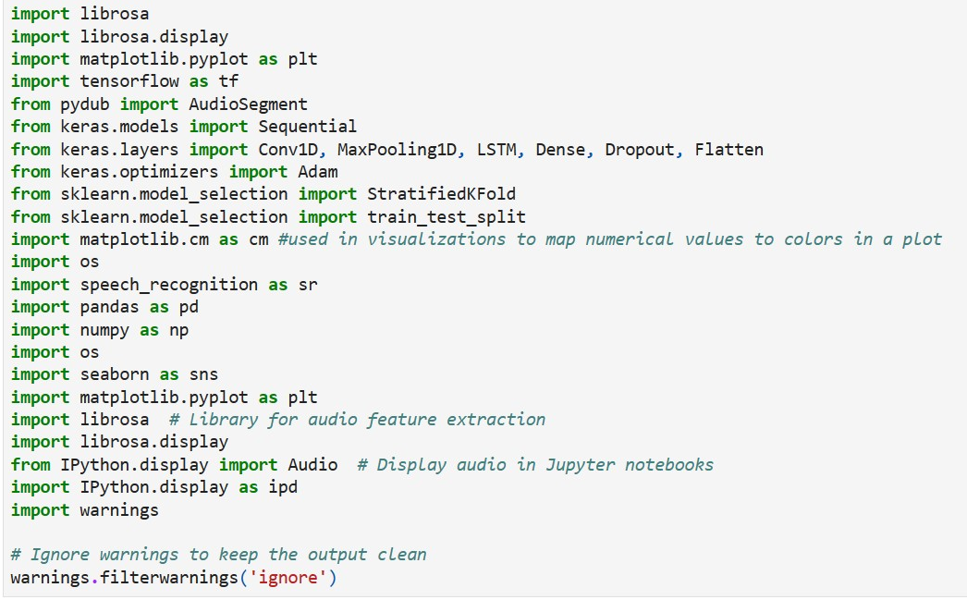

1. This code reads audio files containing emotions, divides them based on their file paths and emotion types, and stores each unit separately in their respective arrays. It walks through a specified directory, gathers file paths, and extracts emotion labels from directory names, organizing this information into two lists: one for file paths (paths) and another for emotion labels (labels). The paths list holds the full file paths of the audio units, while the labels list corresponds to the emotion labels associated with each unit.

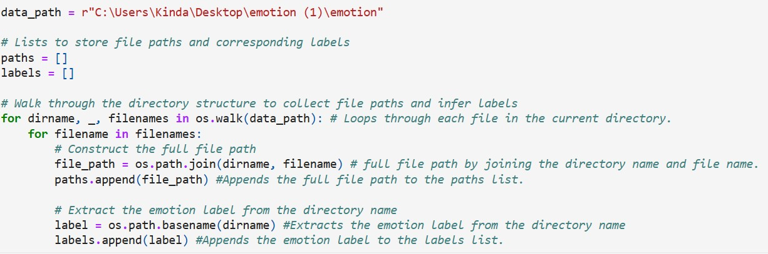

1. This code uses Pandas to create a DataFrame (df) with emotion labels and file paths. It then extracts one path per unique emotion into a new DataFrame (df_one_per_emotion). Finally, the original DataFrame (df) is updated with emotion labels and file paths, and the resulting DataFrame (df_one_per_emotion) is displayed.

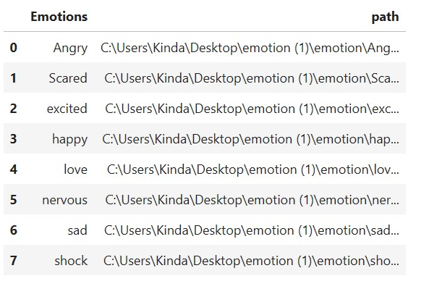

1. Count the number of each emotion

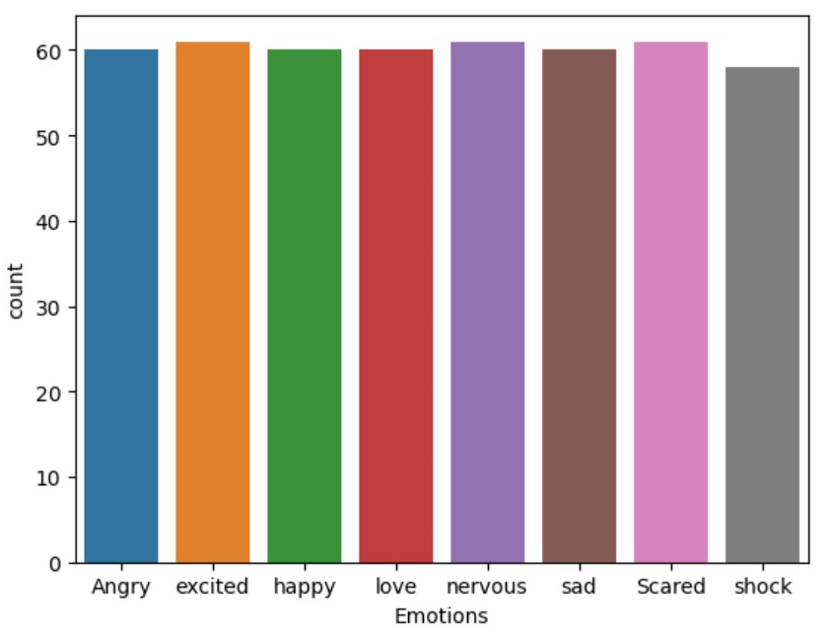 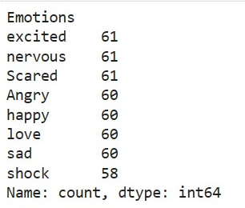

1. This Python script uses the SpeechRecognition library to transcribe audio files in a specified directory. The script iterates through emotion-labeled subdirectories, processes each audio file, and saves the transcriptions along with emotion labels to an Excel file.

Note: Not all voices may be successfully converted to text due to variations in speech clarity or language understanding limitations.

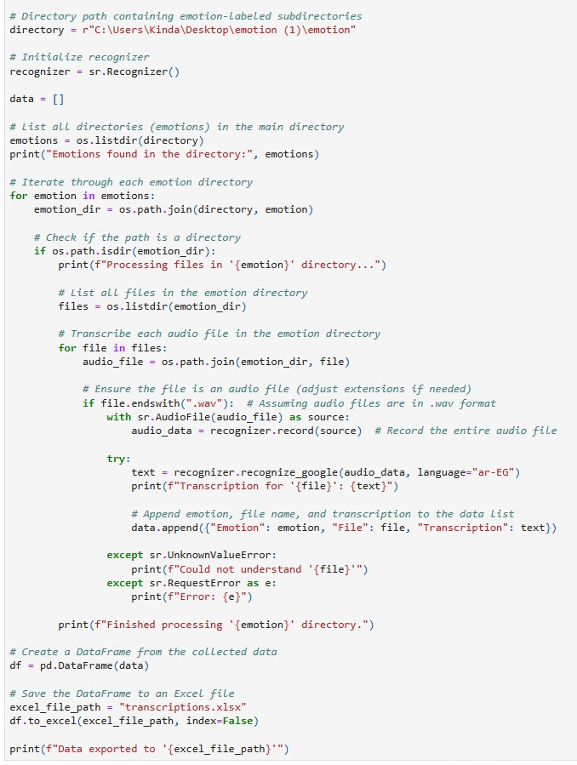

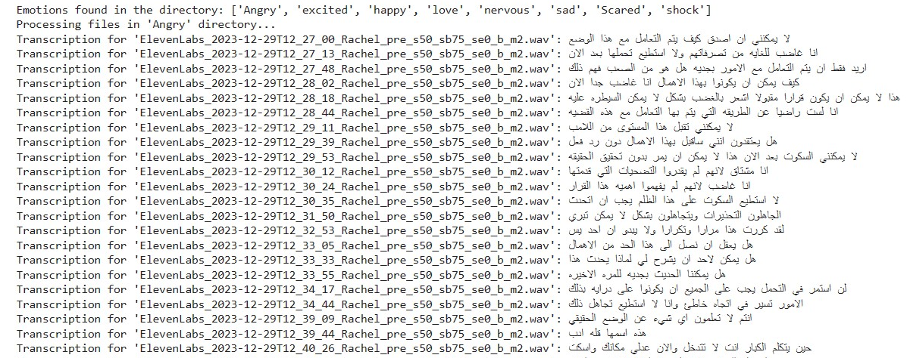

1. This script extracts Mel-frequency cepstral coefficients (MFCCs) as features from audio files using the Librosa library. It iterates through emotion-labeled subdirectories, processes each audio file, calculates MFCCs, and saves the features along with emotion labels to a CSV file.

Note: not all audio files may be processed successfully, and any errors encountered during processing will be printed.

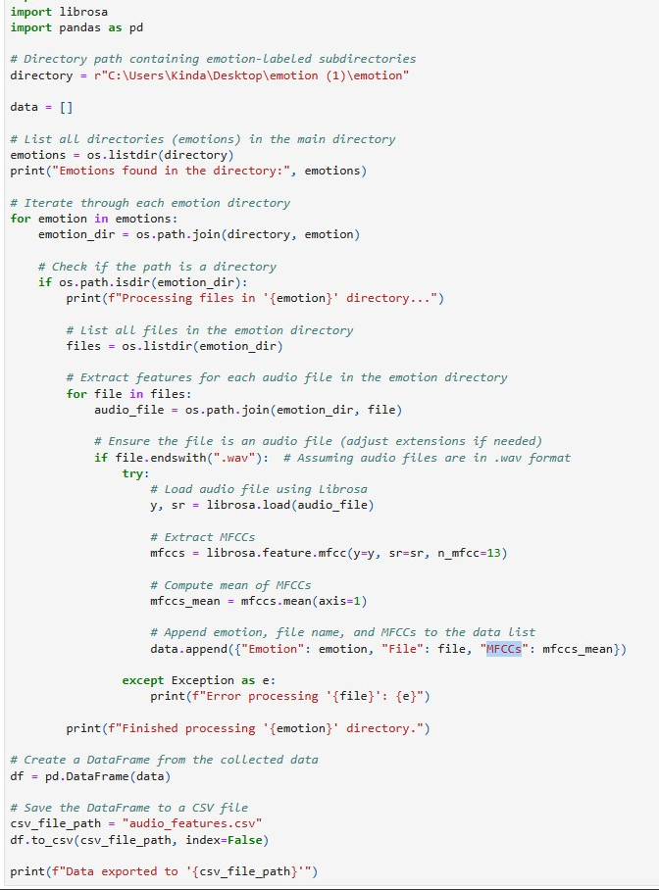

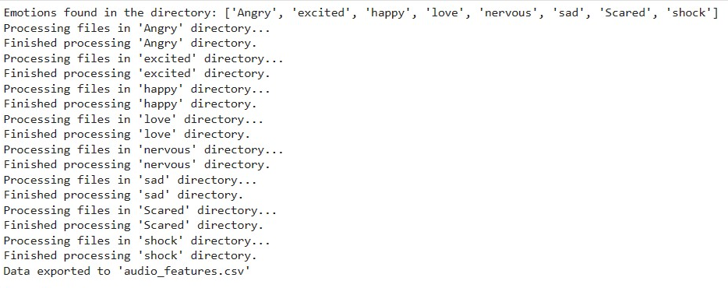

1. The script merges transcription data from an Excel file with audio features (MFCCs) data from a CSV file based on the 'File' column using an inner join. The resulting dataframe (df) contains a combination of transcription and audio features, providing a consolidated view of the data. The head() function is used to display the initial rows of this merged dataframe.

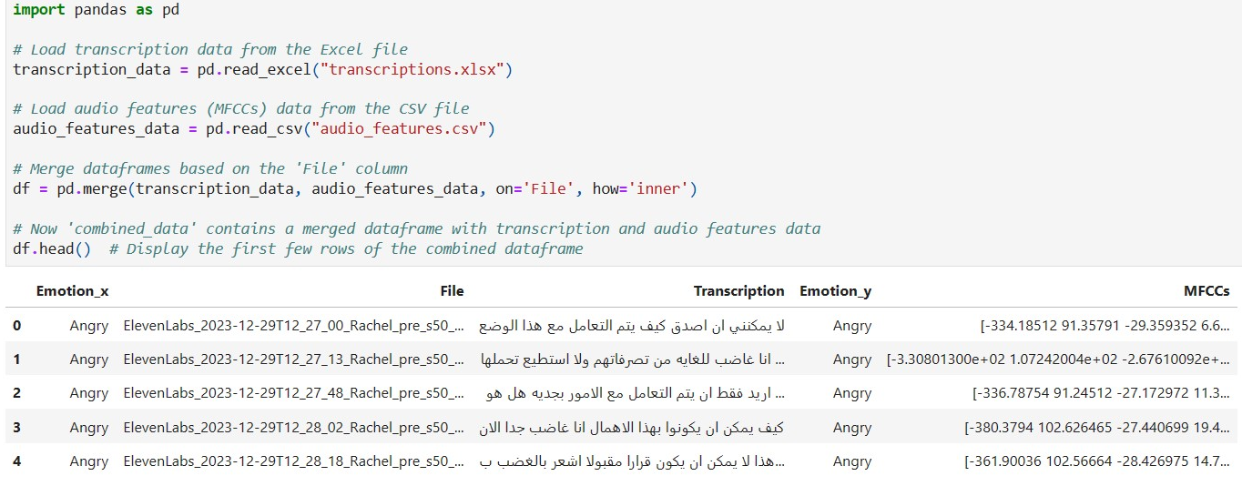

1. The script begins by filtering the DataFrame (df) based on conditions for non-null values in the 'MFCCs' and 'Transcription' columns. It then proceeds to extract numerical features (MFCCs) and text features (Transcription) from the filtered DataFrame. To prepare the numerical features for scaling, the 'MFCCs' column is cleaned and converted to a numeric format, and the MFCCs are stacked into a 2D array. Subsequently, the script initializes a StandardScaler and applies it to scale the numerical data. The resulting scaled numerical features are printed. It's important to ensure that the required libraries (numpy, scipy, sklearn) are installed before executing the script.

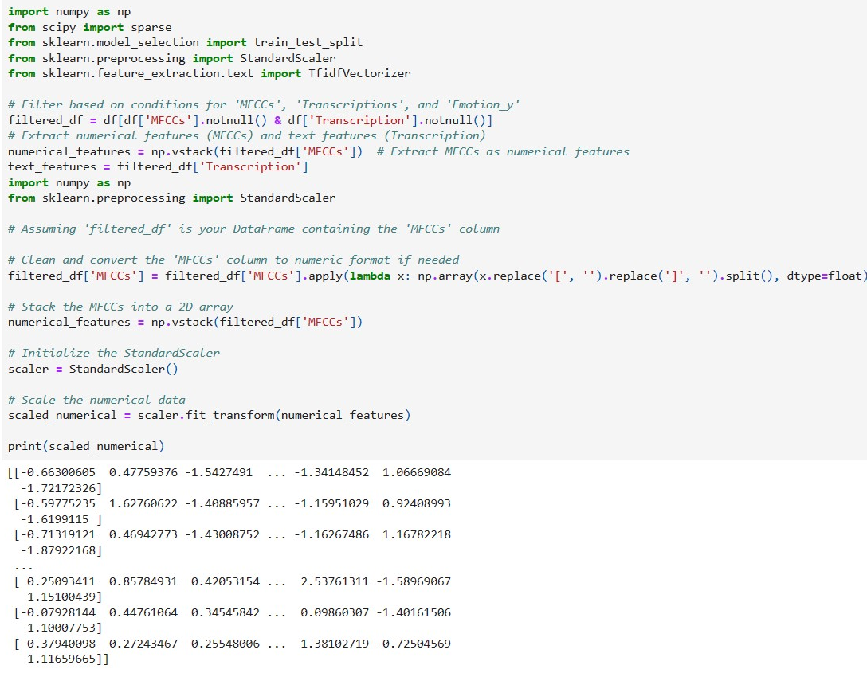

1. The script uses TfidfVectorizer to convert text features (text_features) to numerical representation. It defines the target variable (labels) and encodes it into numerical values using LabelEncoder. The script combines TF-IDF vectorized text features with numerical features (MFCCs) into a single array (combined_data). Finally, it splits the combined data and labels into training and testing sets (x_train, x_test, y_train, y_test) for machine learning model training using train_test_split. Ensure that the required libraries (numpy, scipy, sklearn) are installed before running the script.

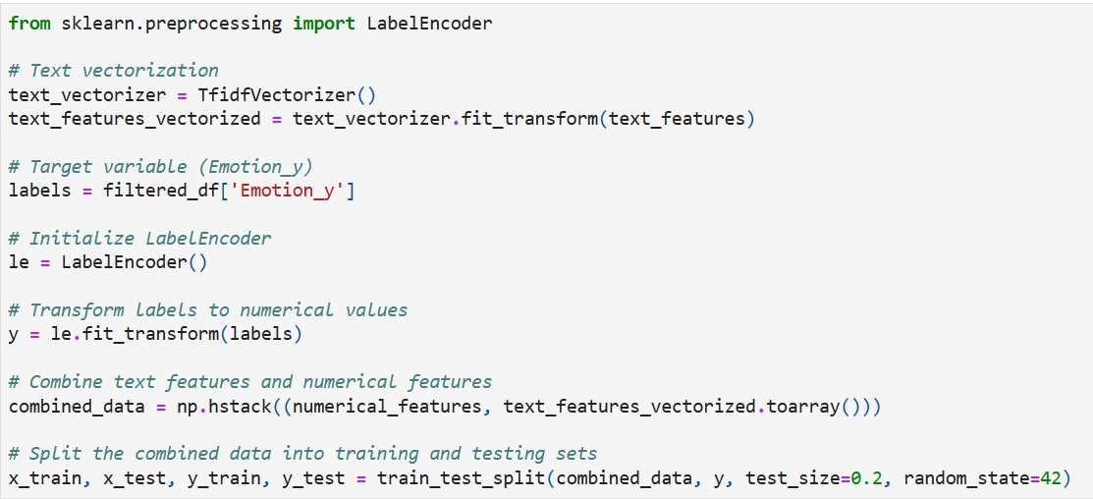

1. This script utilizes the scikit-learn LabelEncoder to encode and decode emotions into numerical values. It first initializes the LabelEncoder and fits it to the provided emotion list, which includes "Angry," "Shock," "Excited," "Happy," "Love," "Nervous," "Sad," and "Scared." The script then prints the classes learned by the LabelEncoder, transforms the emotions into numerical values, and inversely transforms them back to obtain the original emotions. The output includes the learned classes, the numerical representation of emotions, and the decoded emotions.

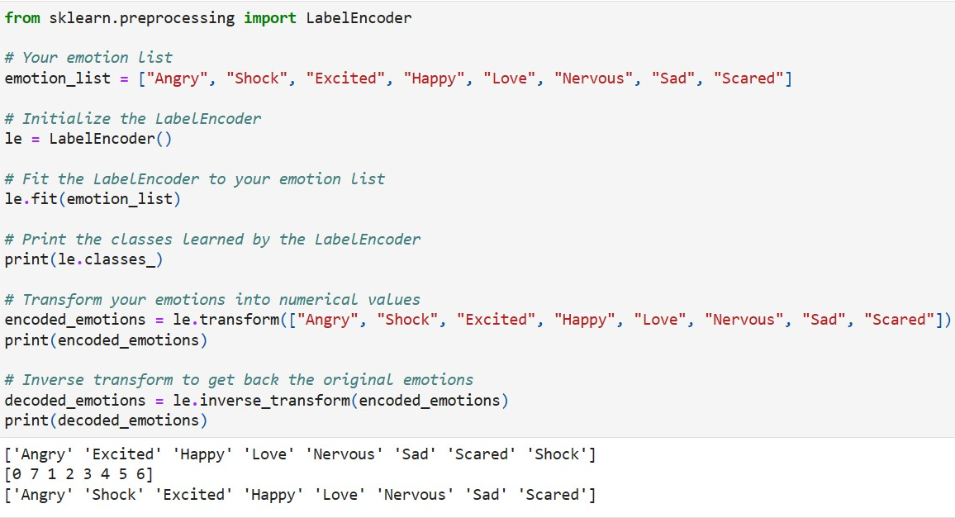

1. This script utilizes scikit-learn's train_test_split function to split the combined data (combined_data) and corresponding labels (y) into training and testing sets. The split is performed with a test size of 20% and a specified random state for reproducibility.

After the split, the script prints the shapes of the resulting training and testing sets (x_train, y_train, x_test, y_test). Additionally, it prints the shape of the original DataFrame (df). These outputs provide information about the sizes of the training and testing datasets as well as the overall shape of the original DataFrame.

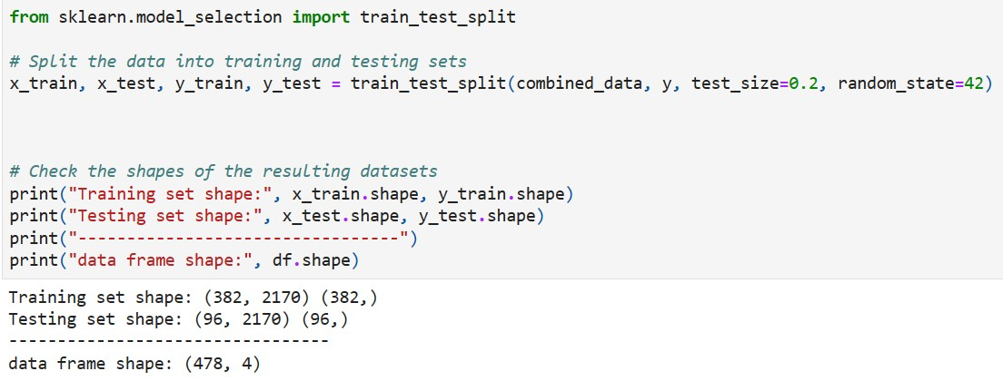

1. This script defines a Sequential model using Keras with layers such as Conv1D, MaxPooling1D, LSTM, and Dense. The model is compiled using the Adam optimizer and sparse categorical crossentropy loss. It is then trained on the provided training data (x_train, y_train) for 30 epochs with a batch size of 64. The validation data (x_test, y_test) is used to evaluate the model's performance during training.

Note: Ensure that you have the Keras library installed (pip install keras) before running the script. Additionally, adjust the input shape of the first layer according to the shape of your data. The current input shape assumes a one-dimensional data with 2170 time steps and 1 feature.

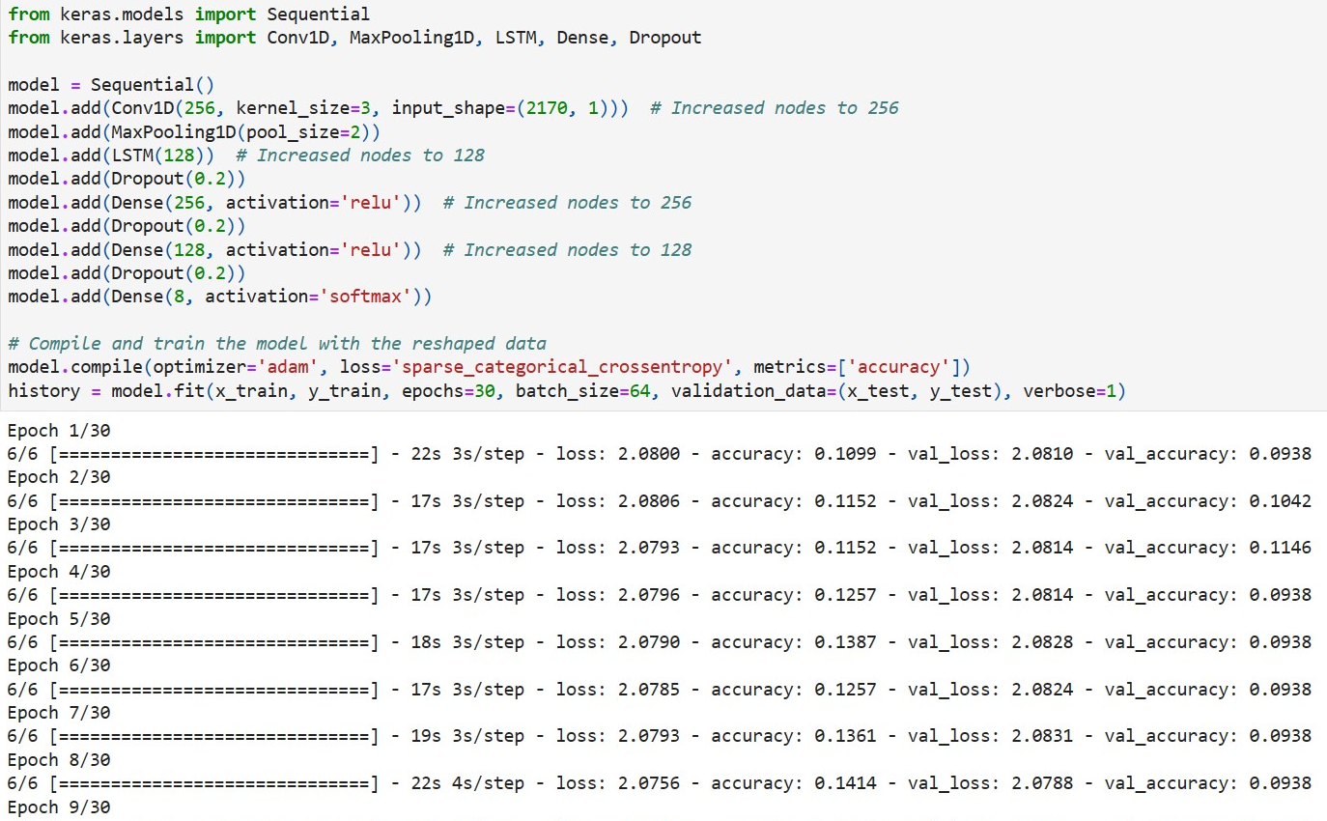

1. This code visualizes the changes in training and validation accuracy over epochs using Matplotlib. It provides a quick snapshot of the model's learning progress

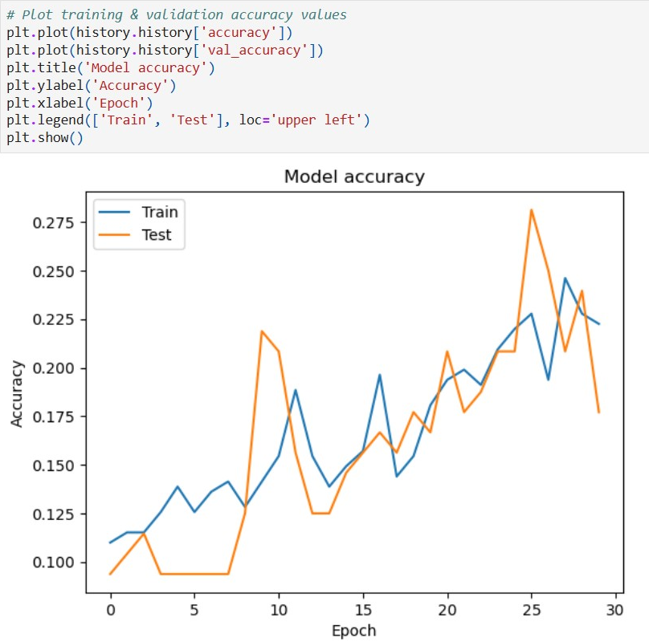

1. This code visualizes the training and validation loss over epochs for a neural network model using Matplotlib.

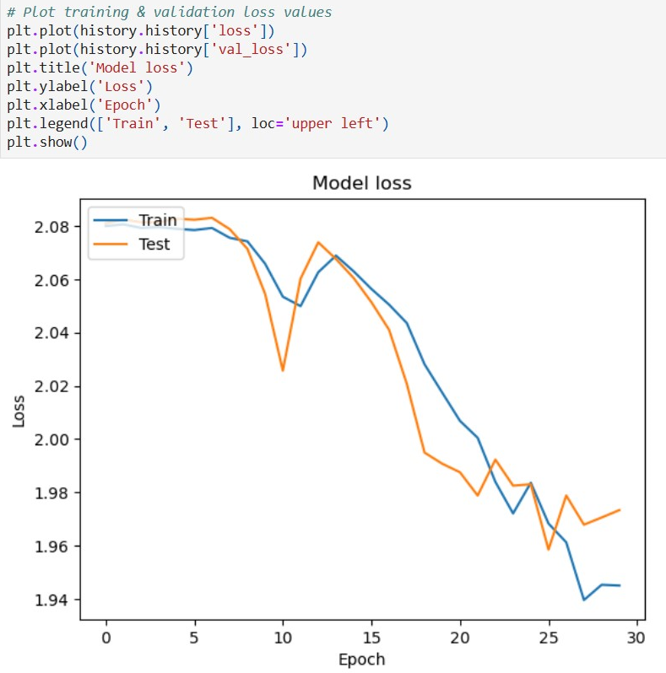

Conclusion:

In our research, we delve into two key aspects. Firstly, we explore models predicting emotions based on frequencies, where each frequency corresponds to emotions like shock, happiness, or sadness. In the second part, we examine the integration of features from both text and frequencies. Notably, our findings reveal that models leveraging features from frequencies outperform those relying solely on text features. This emphasizes that data quality isn't the sole determinant; understanding emotion frequencies is crucial. Given that AI lacks inherent emotions, challenges arise in training models effectively. Consequently, our conclusion advocates for augmenting our dataset with more diverse emotional data to enhance the model's predictive capabilities.